

Updated: 1/4/2022

**QUARANTINE**

**DROPLET/CONTACT**

**PRECAUTIONS**

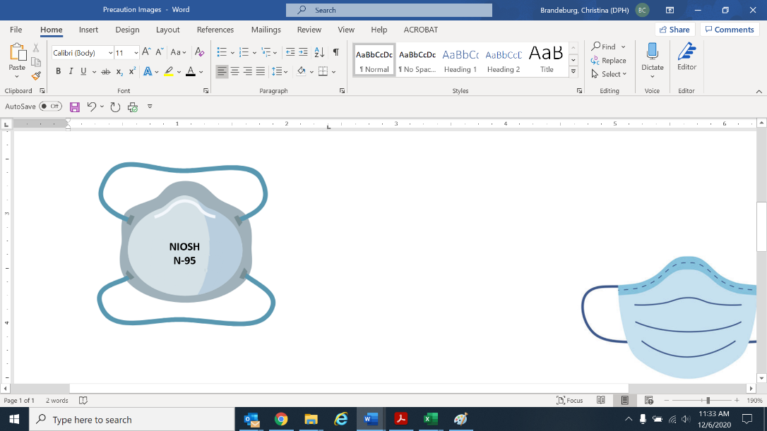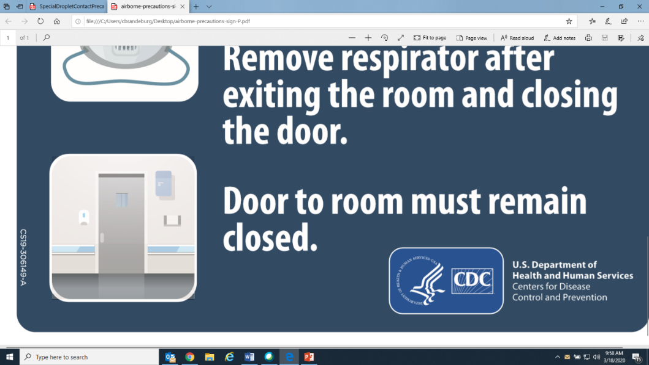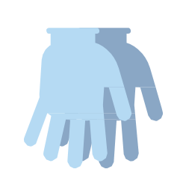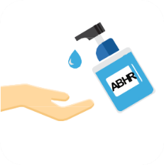

***Contact Infection*** ***Preventionist prior to discontinuing Precautions***

**In addition to Standard Precautions**

**Staff and Providers MUST:**

**KEEP DOOR CLOSED**

(When performing an aerosol-generating procedure)

**Clean hands:** when entering and exiting

|  |  |  |  |
| --- | --- | --- | --- |
| **Gown**  (For high-contact care and MUST change between residents) | **N95 Respirator**  (Facemask acceptable if N95 not available; fit tested N-95 or higher required for AGPs) | **Eye Protection**  (Face shield or googles) | **Gloves**  (For high-contact care, and MUST change between residents) |

**Use patient dedicated or disposable equipment.**

**Clean and disinfect shared equipment.**