|  |
| --- |
| Center for HEalth Information and Analysis |
| Data Submission Manual  Nursing Facility Weekly Reporting |
|  |
| **Updated May 15, 2020** |



**Table of Contents**

**1. Introduction** 2

**2. Deadlines and Data Periods** 2

**4. Submission Instructions** 2

**5. Field Definitions** 3

**Appendix A: Guidance on Reporting Resident and Staff COVID-19 Status** 8

**Appendix B: Detailed Submission Instructions** 9

# **1. Introduction**

Pursuant to [MassHealth Nursing Facility Bulletin 145](https://www.mass.gov/doc/nursing-facility-bulletin-145-infection-control-competencies-and-expectations-for-nursing/download), issued April 2020, nursing facilities participating in MassHealth are required to submit weekly reports to the Center for Health Information and Analysis (CHIA) to monitor measures related to staffing levels, COVID-19 cases, PPE, and other metrics.

# **2. Deadlines and Data Periods**

Nursing facility providers shall submit data for each facility every Monday, with information reflecting the previous week (the previous Monday through Sunday, midnight to midnight). The table below outlines the due dates and the dates that each data submission reflects. Data is due at 11:59pm on the due date. All dates below are for calendar year 2020.

|  |  |  |
| --- | --- | --- |
| **Due Date** | **Data Period Begin Date** | **Data Period End Date** |
| Monday, May 11 | Monday, 5/4 | Sunday, 5/10 |
| Monday, May 18 | Monday, 5/11 | Sunday, 5/17 |
| Monday, May 25 | Monday, 5/18 | Sunday, 5/24 |
| Monday, June 1 | Monday, 5/25 | Sunday, 5/31 |
| Monday, June 8 | Monday, 6/1 | Sunday, 6/7 |
| Monday, June 15 | Monday, 6/8 | Sunday, 6/14 |
| Monday, June 22 | Monday, 6/15 | Sunday, 6/21 |
| Monday, June 29 | Monday, 6/22 | Sunday, 6/28 |
| Monday, July 6 | Monday, 6/29 | Sunday, 7/5 |

# **4. Submission Instructions**

Nursing facilities shall submit the weekly report using the [CHIA submissions](https://chiasubmissions.chia.state.ma.us/NFWeeklyReport) web portal, available at [https://chiasubmissions.chia.state.ma.us/NFWeeklyReport.](https://chiasubmissions.chia.state.ma.us/NFWeeklyReport)Submitters will access the web based survey using the **username**: nursinghomereport and **password**: weeklyreport1.

Once logged in, the submitter will click on the submitting nursing facility provider name on the left-hand menu, and proceed to enter the data into the fields. When completed, the submitter will press **Submit**. The submitter will be prompted to confirm the nursing facility for which they are submitting. **Detailed instructions with screenshots are available in Appendix B of this submission guide.**

For technical assistance, please email [CHIANursingFacilityData@state.ma.us](mailto:CHIANursingFacilityData@state.ma.us).

# **5. Field Definitions**

Nursing facility providers will submit data for the following fields in accordance with the definitions below. All fields are required.

Data Notes:

* Total staff is defined as all clinical and non-clinical full-time, part-time, and per diem employees and contractors employed by the nursing facility on May 7, 2020, but not including staff employed through temporary nurse staffing agencies or staff provided at the Commonwealth’s expense (such as those provided by EOHHS through a clinical rapid response team or the Massachusetts National Guard). Staff that are per diem employees will be included in the definition if they had worked at the facility within one week before or are scheduled to work at the facility within one week after May 7, 2020.
* Current Period is defined as the seven-day data period, outlined in Section 2. Deadlines and Data Periods.
* Cumulative is defined as from January 1, 2020 through the last day of the reporting period.
* The total number of COVID-19 positive, negative, recovered, and status unknown for the current period should equal the total number of residents and staff. COVID-19 status is as of the last day of the data period. See **Appendix A: Guidance on Reporting Resident and Staff COVID-19 Status** for more detail.

| **Data Field** | **Instructions** |
| --- | --- |
| 1. **Report Information** | |
| Facility Name | Select the facility submitting data from the list. |
| Period Begin Date | Select the first date of data period by clicking on the calendar icon. See section 2 Deadlines and Data Periods. |
| Period End Date | Select the last date of data period by clicking on the calendar icon. See section 2 Deadlines and Data Periods. |
| 1. **Census** | |
| Average Daily Census | Enter the number of nursing facility residents in the facility each day, averaged across the seven-day data period. |
| Total Residents | Includes all residents of the nursing facility **as of May 7, 2020**, except those that are on medical or non-medical leave of absence. |
| 1. **COVID-19 Cases and Mortality** | |
| Residents: COVID-19 Status Confirmed Positive, Cumulative | Enter the total number of unique residents who remained for at least 24 hours at the facility with a confirmed COVID-19 positive diagnosis since January 1, 2020. This should include residents who have since been discharged to another setting, recovered, or who are deceased. |
| Residents: COVID-19 Status Confirmed Positive, Current Period | Enter the number of residents who have a positive test result AND are currently being treated as positive, including residents who remain in the facility, as well as residents who were transferred out, admitted to another facility, or died. Do not include people here who are *presumed* positive or recovered |
| Residents: COVID-19 Status Presumed Positive (Awaiting Test Results), Current Period | Enter the number of residents who have been or are currently managed as though they have COVID-19 (but do not yet have a laboratory positive COVID-19 test result) since the last date that suspected COVID-19 counts were entered, including residents who remain in the NF, as well as residents who were transferred out of the facility, admitted to another facility, or died. |
| Residents: COVID-19 Status Presumed Positive (Not Yet Tested), Current Period | Enter the number of residents who are CURRENTLY presumed positive COVID-19 but have not been tested and are not awaiting test results. |
| Residents: COVID-19 Status Confirmed Negative, Current Period | Enter the total number of individual residents who received a negative COVID-19 test result, as of the last day of the reporting period, OR who were confirmed negatives in a previous data period and are still treated as confirmed negatives per CDC/DPH infection control guideline. Do not include recovered residents, whether or not they have been retested; please include all recovered residents in the “Recovered” group. |
| Residents: COVID-19 Status Recovered (Not Yet Retested), Current Period | Enter the total number of individual residents who had previously received a positive COVID-19 test result, but are considered recovered, who have not yet received a negative COVID-19 test result, as of the last day of the reporting period. |
| Residents: COVID-19 Status Unknown (Not Yet Tested), Current Period | Enter the total number of individual residents who have not yet been tested for COVID-19. |
| Residents: COVID-19 Status Unknown (Awaiting Test Results; Not Presumed Positive), Current Period | Enter the total number of individual residents who received a COVID-19 test, who have not yet received test results, but are being treated as COVID-19 negative, as of the last day of the reporting period. |
| Residents: COVID-19 Deaths, Cumulative | Enter the number of residents who passed away, since January 1, 2020, where COVID-19 is reported as a cause that contributed to death on the death certificate. These should include confirmed, probable, and suspected COVID-19 classifications. This includes residents that died in the NF or in another location. |
| Staff: COVID-19 Status Confirmed Positive, Cumulative | Enter the number of residents who have a positive test result AND are currently being treated as positive, including residents who remain in the facility, as well as residents who were transferred out, admitted to another facility, or died. Do not include people here who are *presumed* positive or recovered. |
| Staff: COVID-19 Status Confirmed Positive Symptomatic, Current Period | Enter the total number of staff who received a positive COVID-19 diagnosis as a result of a laboratory test who expressed clinical symptoms (including fever, chills, shaking chills, muscle pain, headache, sore throat, or new loss of taste or smell) during the seven day data period. This number should be a subset of all COVID-19 confirmed positive staff. |
| Staff: COVID-19 Status Current Confirmed Positive Asymptomatic, Current Period | Enter the total number of staff who received a positive COVID-19 diagnosis as a result of a laboratory test who did not expressed clinical symptoms (including fever, chills, shaking chills, muscle pain, headache, sore throat, or new loss of taste or smell) during the seven day data period. This number should be a subset of all COVID-19 confirmed positive staff. |
| Staff: COVID-19 Status Presumed Positive (Awaiting Test Results), Current Period | Enter the number of staff who have been or are newly managed as though they have COVID-19 (but do not have a laboratory positive COVID-19 test result) since the last date that suspected COVID-19 counts were entered. |
| Staff: COVID-19 Status Presumed Positive (Not Yet Tested), Current Period | Enter the number of staff who are presumed to have COVID-19 but have not yet been tested since the last date that counts were entered. |
| Staff: COVID-19 Status Confirmed Negative, Current Period | Enter the total number of individual staff who received a negative COVID-19 test result, as of the last day of the data period, OR who were confirmed negatives in a previous data period and are still treated as confirmed negatives per CDC/DPH infection control guideline |
| Staff: COVID-19 Status Recovered (No Negative Test), Current Period | Enter the total number of individual staff who had previously received a positive COVID-19 test result, but are considered recovered, who have not yet received a negative COVID-19 test result, as of the last day of the reporting period. |
| Staff: COVID-19 Status Unknown (Not Yet Tested), Current Period | Enter the total number of individual staff whose COVID-19 status is unknown, and who have not yet been tested as of the last day of the reporting period. |
| Staff: COVID-19 Status Unknown (Awaiting Test Results; Not Presumed Positive), Current Period | Enter the total number of individual staff who received a COVID-19 test, who have not yet received test results, but are being treated as COVID-19 negative, as of the last day of the reporting period. |
| Staff: COVID-19 Deaths, Cumulative | Enter the number of staff who passed away, and had previously worked at the facility since January 1, 2020, when COVID-19 is reported as a cause that contributed to death on the death certificate. These should include confirmed, probable, and suspected COVID-19 classifications. |
| 1. **COVID-19 Testing** | |
| Residents Tested, Cumulative | Enter the total number of unique residents that have received tests for COVID-19 since April 8th. Include residents even for whom test results were not yet reported. Do not count a resident more than once, even if they were tested more than once. |
| Staff Tested, Cumulative | Enter the total number of unique staff that have received tests for COVID-19 since April 8th. Include staff even for whom test results were not yet reported. Do not count any individual more than once, even if they were tested more than once. |
| 1. **Staffing** | |
| Total Staff Count | Total staff includes all clinical and non-clinical full-time, part-time, and per diem employees and contractors employed by the nursing facility on **May 7, 2020.** |
| Average Absence Rate: Clinical Staff | Enter the average number of clinical hours (CNAs, RNs, LPNs, as well as other staff primarily serving in those roles), across the most recent seven days, that were absent from expected shifts (not including vacation, personal days, holidays, labor disputes, or maternity leave) during the seven day data period. Staff absences are instances when a staff member is scheduled to work, but does not report to work for their shift and does not provide notice or provided less than 24 hours’ notice that they would be absent. Expressed as a percent of hours absent divided by the hours scheduled, even if the facility was able to fill the absent hours. |
| Average Absence Rate: Non-Clinical Staff | Enter the average number of non-clinical hours (housekeeping, facilities, dietary, administrative) that were absent from expected shifts (not including vacation, personal days, holidays, labor disputes, or maternity leave) across the most recent seven days. Staff absences are instances when a staff member is scheduled to work, but does not report to work for their shift and does not provide notice or provided less than 24 hours’ notice that they would be absent. Expressed as a percent of hours absent divided by the hours scheduled, even if the facility was able to fill the absent hours. |
| Nursing Hours per Resident Day | Enter the number of productive hours worked by CNAs, RNs, and LPNs, as well as other staff serving in those roles, with direct patient care responsibilities **on per patient day basis**. |

**Personal Protective Equipment (PPE) Supply**

Complete the table below. The total remaining column captures the number of each PPE type still available at the facility on the last day of the seven day data period. The total used column captures the number of PPE type used from the first day of the seven day data period through the last day of the seven day data period.

| **PPE** | **Total Remaining** (as of the last day of the seven day data period) | **Total Used**  (total during the 7-day seven day data period) |
| --- | --- | --- |
| N95/KN95 Masks |  |  |
| Other Masks |  |  |
| Gloves (pairs) |  |  |
| Face Shields |  |  |
| Gowns |  |  |

1. **G. Hospital Admissions and Transfers**

Select the hospital name from the drop down menu and report the number of new admissions the facility received from the hospital and the number of transfers to the hospital during the seven day data period.

* New Admissions: the number of unique residents newly admitted to the nursing facility during the seven day data period. This number should include residents previously residing at the facility who were transferred to a hospital or other care setting, and are now returning. Include only newly admitted or readmitted residents since the last weekly report was filed.
* New Transfers: the number of unique residents transferred from the nursing facility to a hospital for hospital-level care needs. This number should reflect residents who remain in the hospital overnight or for more than 24 hours. Include only newly transferred residents since the last weekly report was filed.

|  |  |  |
| --- | --- | --- |
| **Select the Name of the Hospital from the Menu** | **New Admissions**  **from Hospital**  (total during the 7-day seven day data period) | **New Transfers**  **to Hospital**  (total during the 7-day seven day data period) |
|  |  |  |
|  |  |  |
|  |  |  |
|  |  |  |
|  |  |  |

# **Appendix A: Guidance on Reporting Resident and Staff COVID-19 Status**

The total number of COVID-19 positive, presumed positive, negative, and status unknown should equal the total number of residents and staff in your facility.

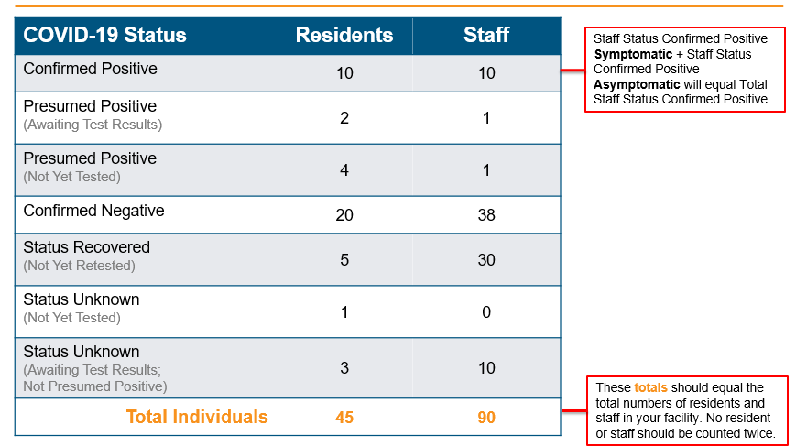

# **Appendix B: Detailed Submission Instructions**

1. Access CHIA’s online submission platform: <https://chiasubmissions.chia.state.ma.us/NFWeeklyReport>
2. Enter the following username and password into the fields indicated by orange arrows in the screenshot below. Then press “login.”
   * Username: nursinghomereport
   * Password: weeklyreport1

**Please Note:** CHIA Submissions works best with Google Chrome.

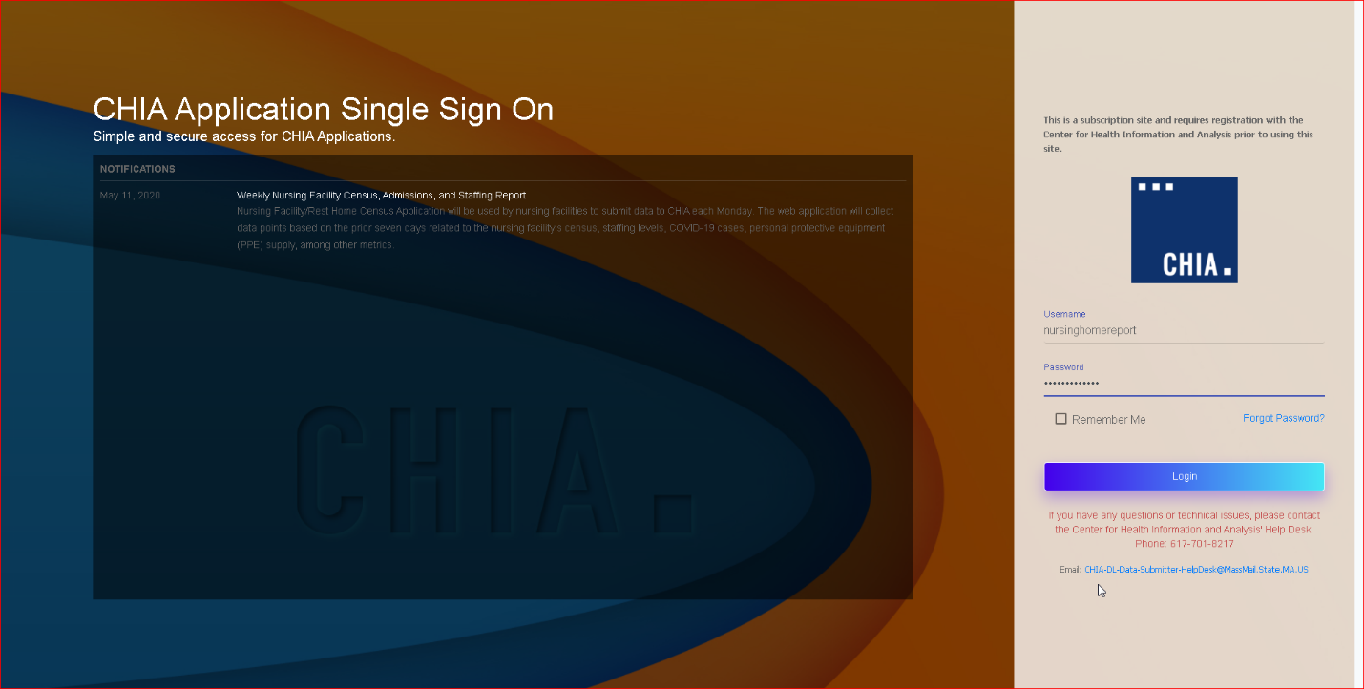

1. Successful access brings you to the report home page. On the left-hand side of the screen will appear a list of nursing facilities. You can enter your facility’s name in the search bar, or scroll to select the facility for which you are reporting. Once you find your facility, click on the name to begin entering data.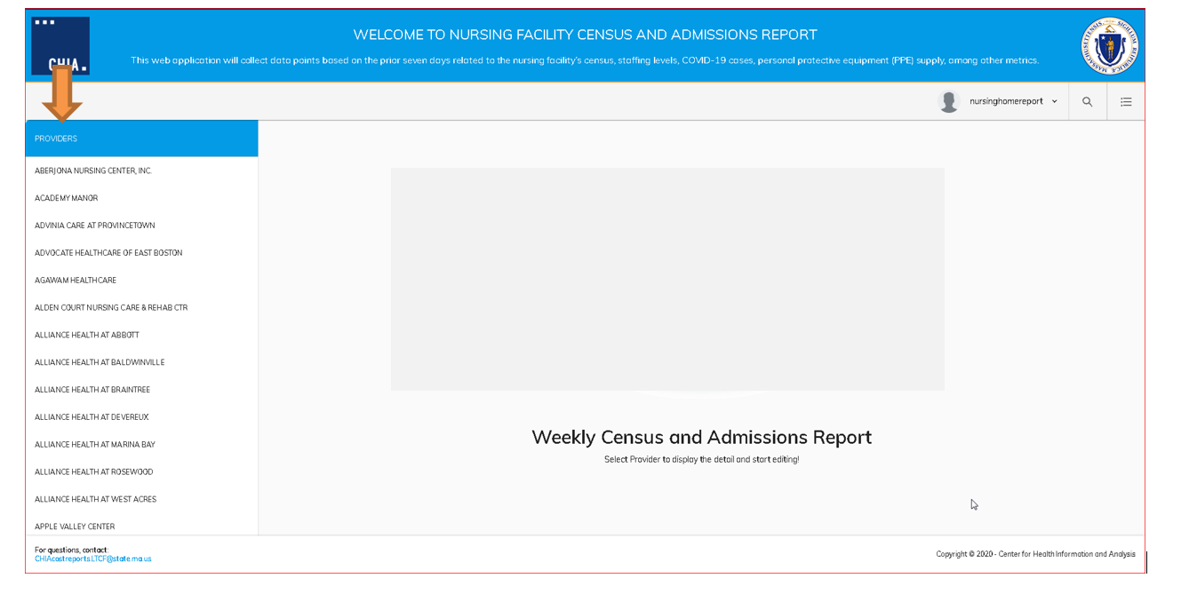
2. Once you select the facility name, next click on the calendar icons to select the date that the data period started and the date that the data period ended. See **2. Deadlines and Data Periods** in this submission guide for guidance on period begin and end dates.

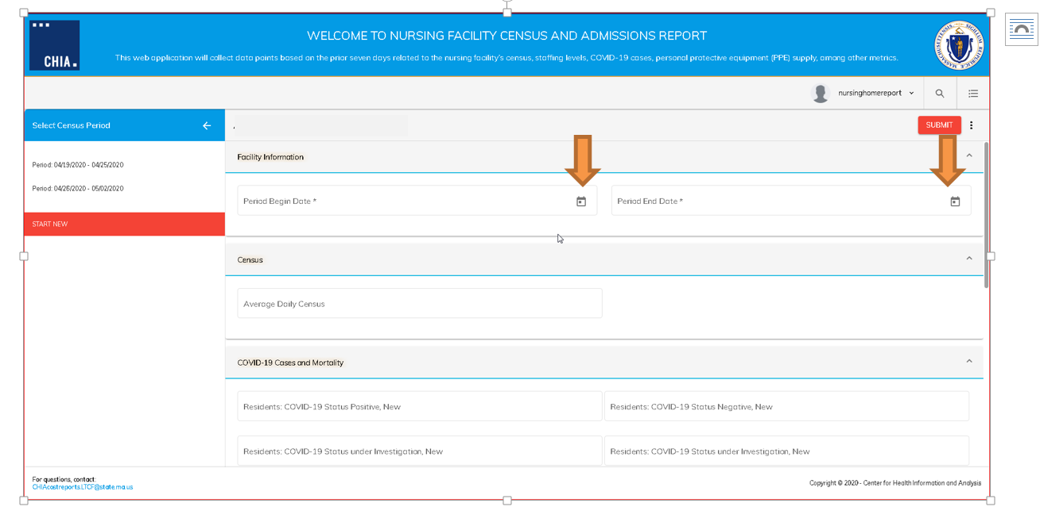

1. Click the button indicated by the orange arrow below to expand all sections in the report. You may also expand and collapse sections by clicking on the caret symbol (v)

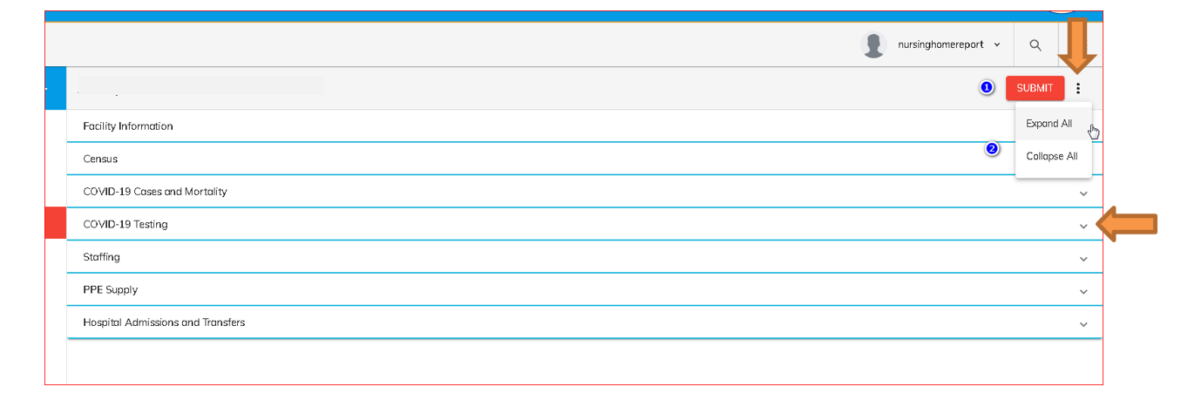

1. Enter data by typing the value into each field.

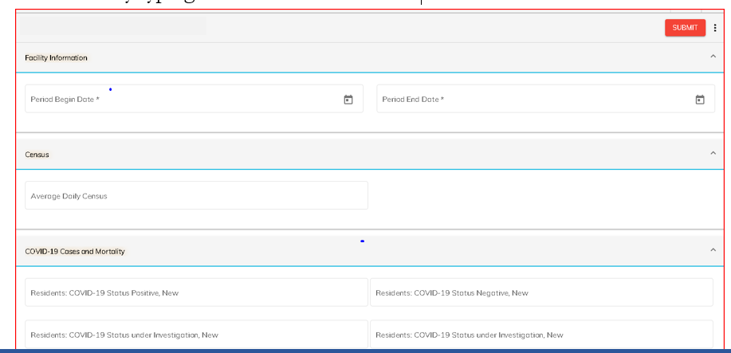

1. To enter hospital admissions and hospital transfers information, click the drop down menu under **Hospital Name** and select a hospital. Next, enter the number of admissions to the facility as well as transfers out of the facility for that hospital. To add another hospital, click the **add row** button.

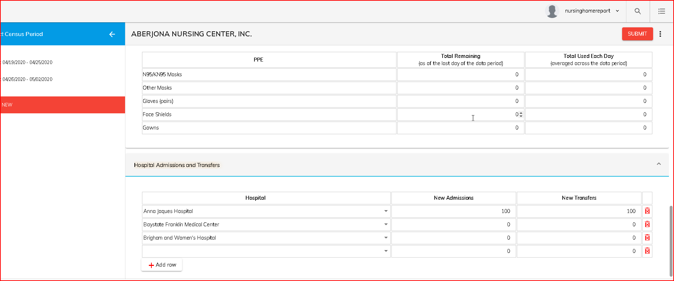

1. When you have finished entering all data, click the red button in the upper right-hand corner that says **Submit**. You will receive a pop-up notice confirming that you wish to submit data for the facility that you selected. If you are ready to submit, click “Yes.” If you selected and entered data for the incorrect facility, click “No” and begin from step 1 above by selecting the correct provider. If you press “Cancel”, the window will close.

**Your submission was received successfully if you receive the message below:**

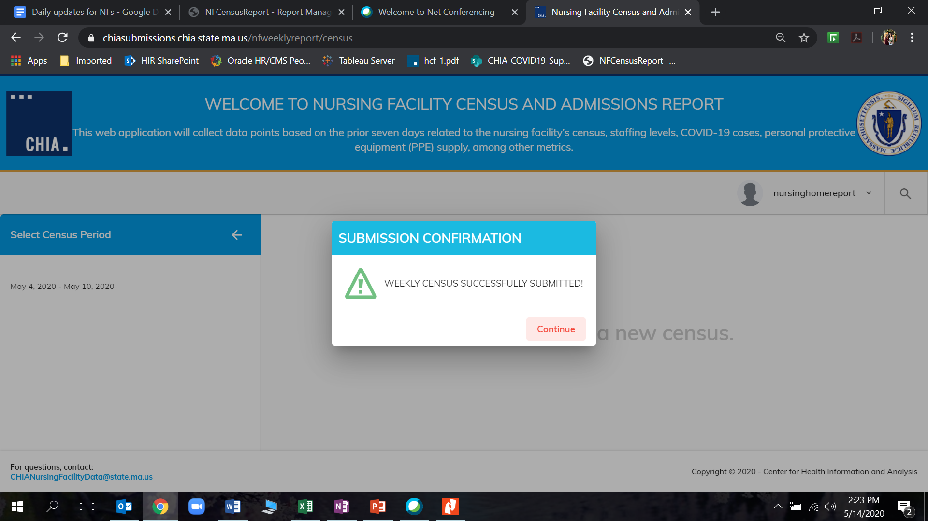

You can also confirm that your submission was received successfully by returning to the Providers list on the left hand side of the webpage. If your facility’s name is highlighted in yellow and displays the symbol, as shown below, then your filing was successfully submitted.

